Configuring Advanced Windows Server

Salman Tabrez Mohmad

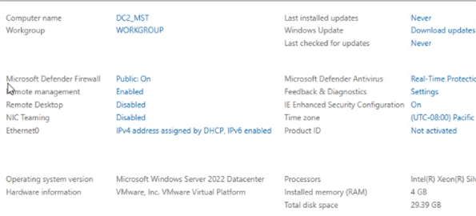

Figure 1: Server 2, Renamed PC as DC2_MST

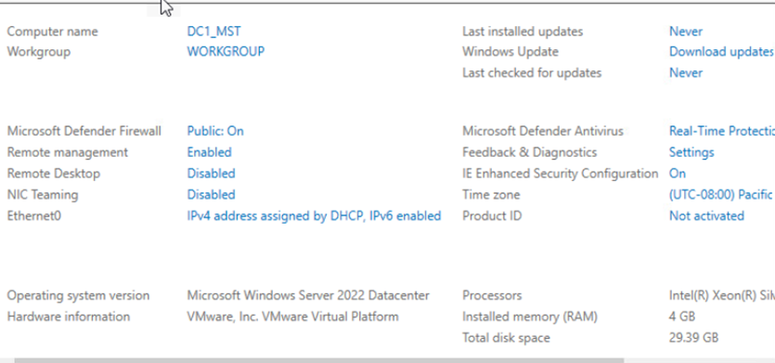

Figure 2: Server 1, Renamed PC as DC1_MST

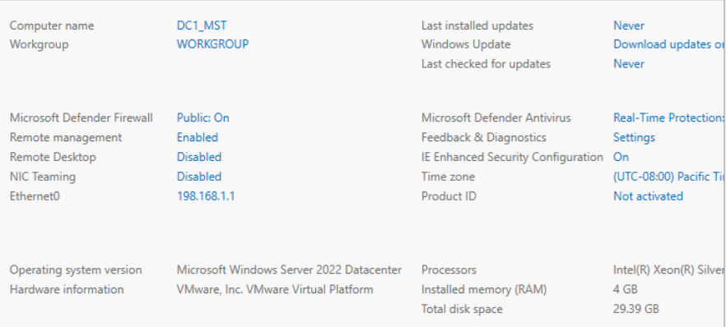

Figure 3: Server 1 setting the static IP address

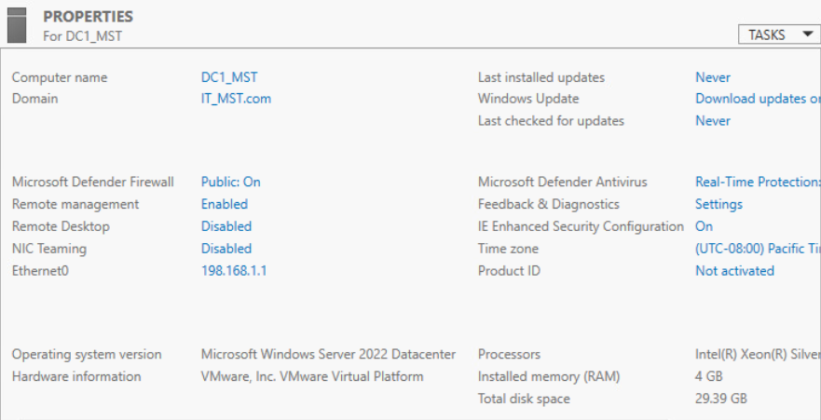

Figure 4: Domain Work Server 1

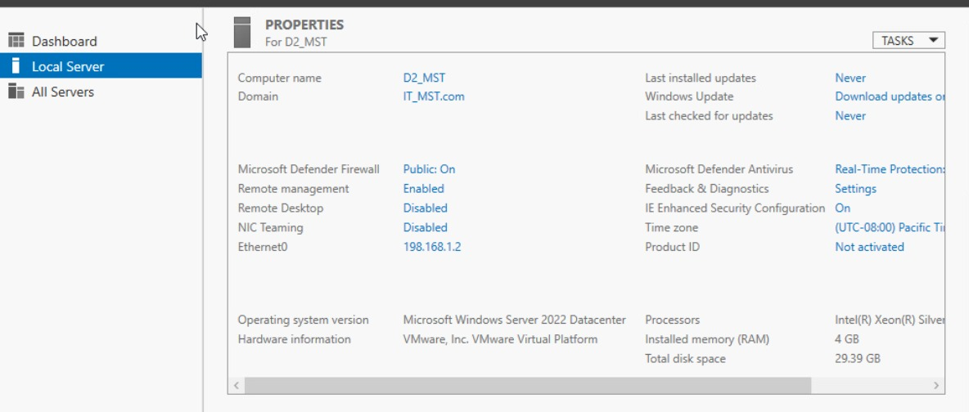

Figure 5: Domain Work Server 2

*Server2*

Figure 6: Workstation

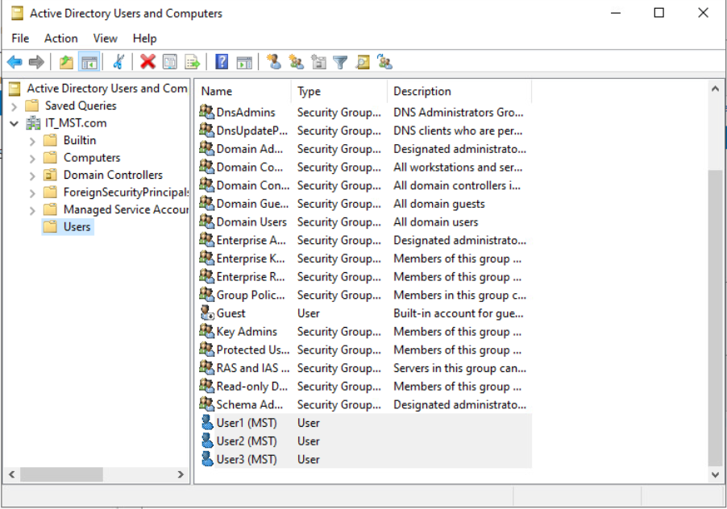

Figure 7: Created Users, User2, User3, User3

Figure 8: Added New York OU and Security Group

Figure 9: Created OU’s and Security Group

Figure 10: Adding User to Miami Sales Group

Figure 11:Configured RAID-5 on Server 2

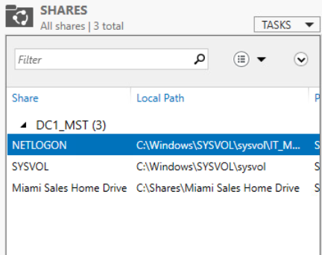

Figure 12: Created SMB Share on Server-1

Figure 13: Mapping the SMB share to the Miami Sales Group on Workstation

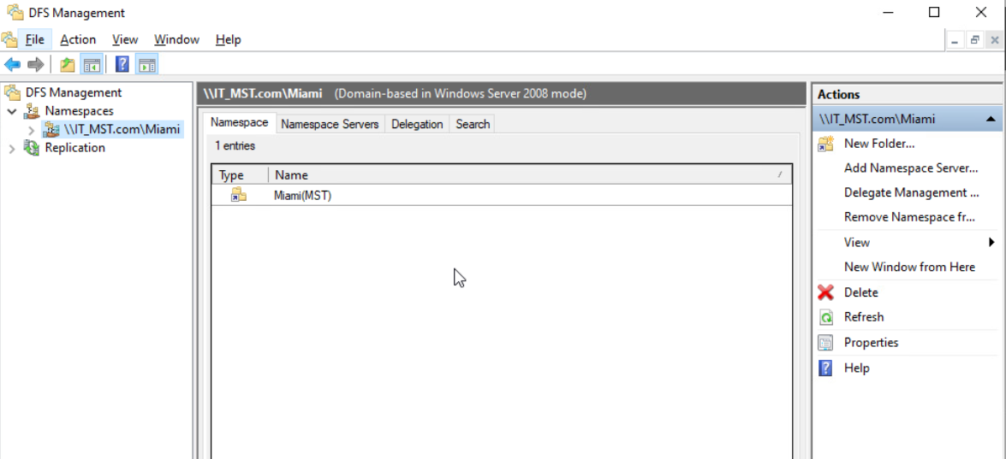

Figure 14: Created a DFS Name Space and added Target to the namespace.

Figure 15: Replication Group Created

Figure 16: Folder Quota, Created a folder with 2 GB limit on Miami Sales Home Drive

Figure 17: File Screen

Figure 18: Adding a new network printer on server 1

Figure 19: Deploying the printer

Figure 20: Deployed Printer is seen on the workstation

Figure 21: A new volume created, Seattle drive on server 2 with 5 GB limit

Figure 22: Enabling Data deduplication with throughput optimization on Seattle Drive

Figure 23: A new storage pool created on server 2

Figure 24: Crafted a fresh Windows scheduled backup, directing it to the Miami Sales Home Drive, and set it to run daily at 6:00 PM

Figure 25: Forward Lookup

Figure 26: SOA’s TTL is modified to 2 hrs

Figure 27: Zone transfers Added to the server 2

Figure 28: Established a novel IPv4 scope, incorporating a printer reservation within the scope. Additionally, adjusted DHCP tolerance, setting the maximum client lead time to 3 hours

Figure 29: Reservation Printer

Figure 30

Figure 31: Server - II is now integrated into the DHCP tolerance system, showing the scope set up on Server - I.

Figure 32: VPN access

Figure 33: Configuring Radius Authentication

Figure 34: A new network policy is created

Figure 35: Generated a fresh Group Policy Object (GPO) targeted at the New York Organizational Unit (OU), and included User1 within the associated security group.

Figure 36: The password policies are all correctly configured; however, I adjusted the minimum password length to 8 characters.

Figure 37: Conducted testing on the workstation by attempting password changes with fewer than 8 characters.

Figure 38: A warning is displayed since the password doesn't meet the complexity requirements.